**Boston University**

**Electrical & Computer Engineering**

**EC464 Senior Design Project II**

**Final Test Report**



Team 4

**Team Members**

Hannah Gold

Jon Ngo

Ben Li

Guillermo Ao

**Required Materials**

**Hardware:**

* Teensy v3.5 Development board (microcontroller)
* Custom PCB
* 2x Electret Microphone Amplifier - MAX4466 with Adjustable Gain
* Audio Adaptor Board for Teensy v3.5 (Audio Shield)
* Earbuds/Headphones with AUX male port
* On/Off switch
* Pushbutton switch
* Rotary Encoder
* 1800 mAh Li-Po Battery & Adafruit Battery Management System

**Software:**

* Arduino IDE + Teensyduino add-on
* Sound-Segregation Algorithm code

**Important equipment description:**

* Teensy v3.5 Microcontroller
  + Used to run the sound-segregation algorithm as well as process the input signals and output them.
* PCB
  + Used to house the various other components and ensure a solid connection.
* Teensy Audio Shield
  + Hardware interface to simplify sound I/O connections to the Teensy microcontroller.
* MAX4466 Electret Microphone Amplifier
  + Used to record incoming bi-channel audio and provide pre-processing amplification
* Earbuds/Headphones
  + Used to output processed sound to user
* On/Off Switch
  + Used to turn the device on and off
* Pushbutton Switch
  + Used as the self-mute button to stop audio processing when the user is talking
* Rotary Encoder
  + Used to adjust the output volume
* 1800 mAh Li-Po Battery & Adafruit Battery Management System
  + Used to power the device and allow for USB recharging through Mini USB

**Set Up**

The hardware setup requires attaching the Teensy microcontroller to the audio shield through a series of pins, much like any other Arduino shield. The microphones will be connected to the respective ADC pins on the audio shield to receive the input signals and the earbuds will be connected to the 3.5mm jack on the audio shield for output. The audio shield uses the I2S interface to control the ADC and DAC connections. The software includes the self-developed sound-segregation algorithm which is in charge of processing the incoming noise signals. The code for the algorithm will already be pre-loaded onto the Teensy device. The general test will be to speak to the user in 3 different angles: first in front of the user at 0 degree, then at 90 degree offsets (directly left or directly right) and observe the attenuation of the output. The sound processing is almost immediate and will be relayed through the earbuds as live audio.

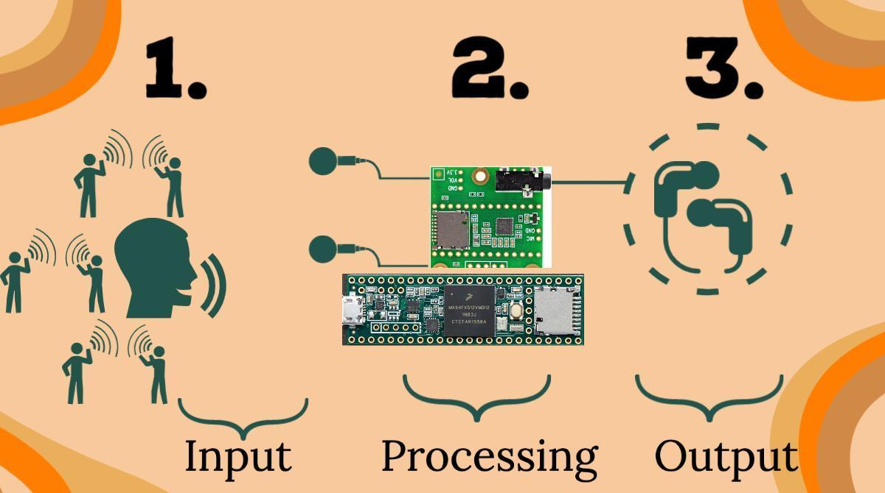

**Figure 1.** Set up and process flow visual

**Pre-testing Setup Procedure**

* Push the sound segregation algorithm code to the Teensy microcontroller.
* Plug in earbuds via audiojack
* Clip the earbuds to microphones
* Flip the On/Off switch to the On position

**Measurable criteria**

The criteria for successful running and output is as follows:

1. The Teensy should be able to receive input sound signals through both left and right microphones.
2. The incoming signals should be processed through the sound processing algorithm, blocking sounds from directly left and right.
3. The device is able to operate for at least 1 hour on battery and is rechargeable.
4. The device fits inside a 120x80x40 mm package.
5. The On/Off switch powers on and off the device
6. The volume knob changes the output level when turned
7. The mute switch stops output when on
8. Sound output from forward direction should be significantly greater than from the sides for frequencies within the range of human speech.

**Measurement Methodology**

**Criteria 1-7: Functional Test**

1. Turn on using the on/off switch.
2. Start speaking in front and on the sides of the user.
3. The signals will start to be processed through the algorithm as the device activates.
4. Audio is processed almost immediately and it will automatically reproduce the output sound through the earbud speakers.
5. Listen to the output sounds.
6. Turn the volume knob through its full range to demonstrate the attenuation capabilities.
7. Instruct the user to speak and listen to their own voices being output.
8. Use the mute button while the user is speaking to demonstrate mute functionality.
9. Allow the device to run for 1 hour and recharge.
10. Turn off using the on/off switch.

**Results:**

The OverEar device draws 65.5 milliamps during normal operation. This translates to an estimated operating time of just over 25 hours with the 1800 mAh battery. Because the battery outputs a constant 3.7 volts, the power consumption of the device is 242.35 milliwatts.

The main electronics (Teensy + Audio shield + battery) are contained in a 25x98x60 mm case (Figure 2) and each microphone will have its own case of size 27 x 18.1 x 8.7 mm (Figure 3) that has clips to attach earbuds for each side. Additionally, the main case has a clip to attach to the user’s waist band of their pants. 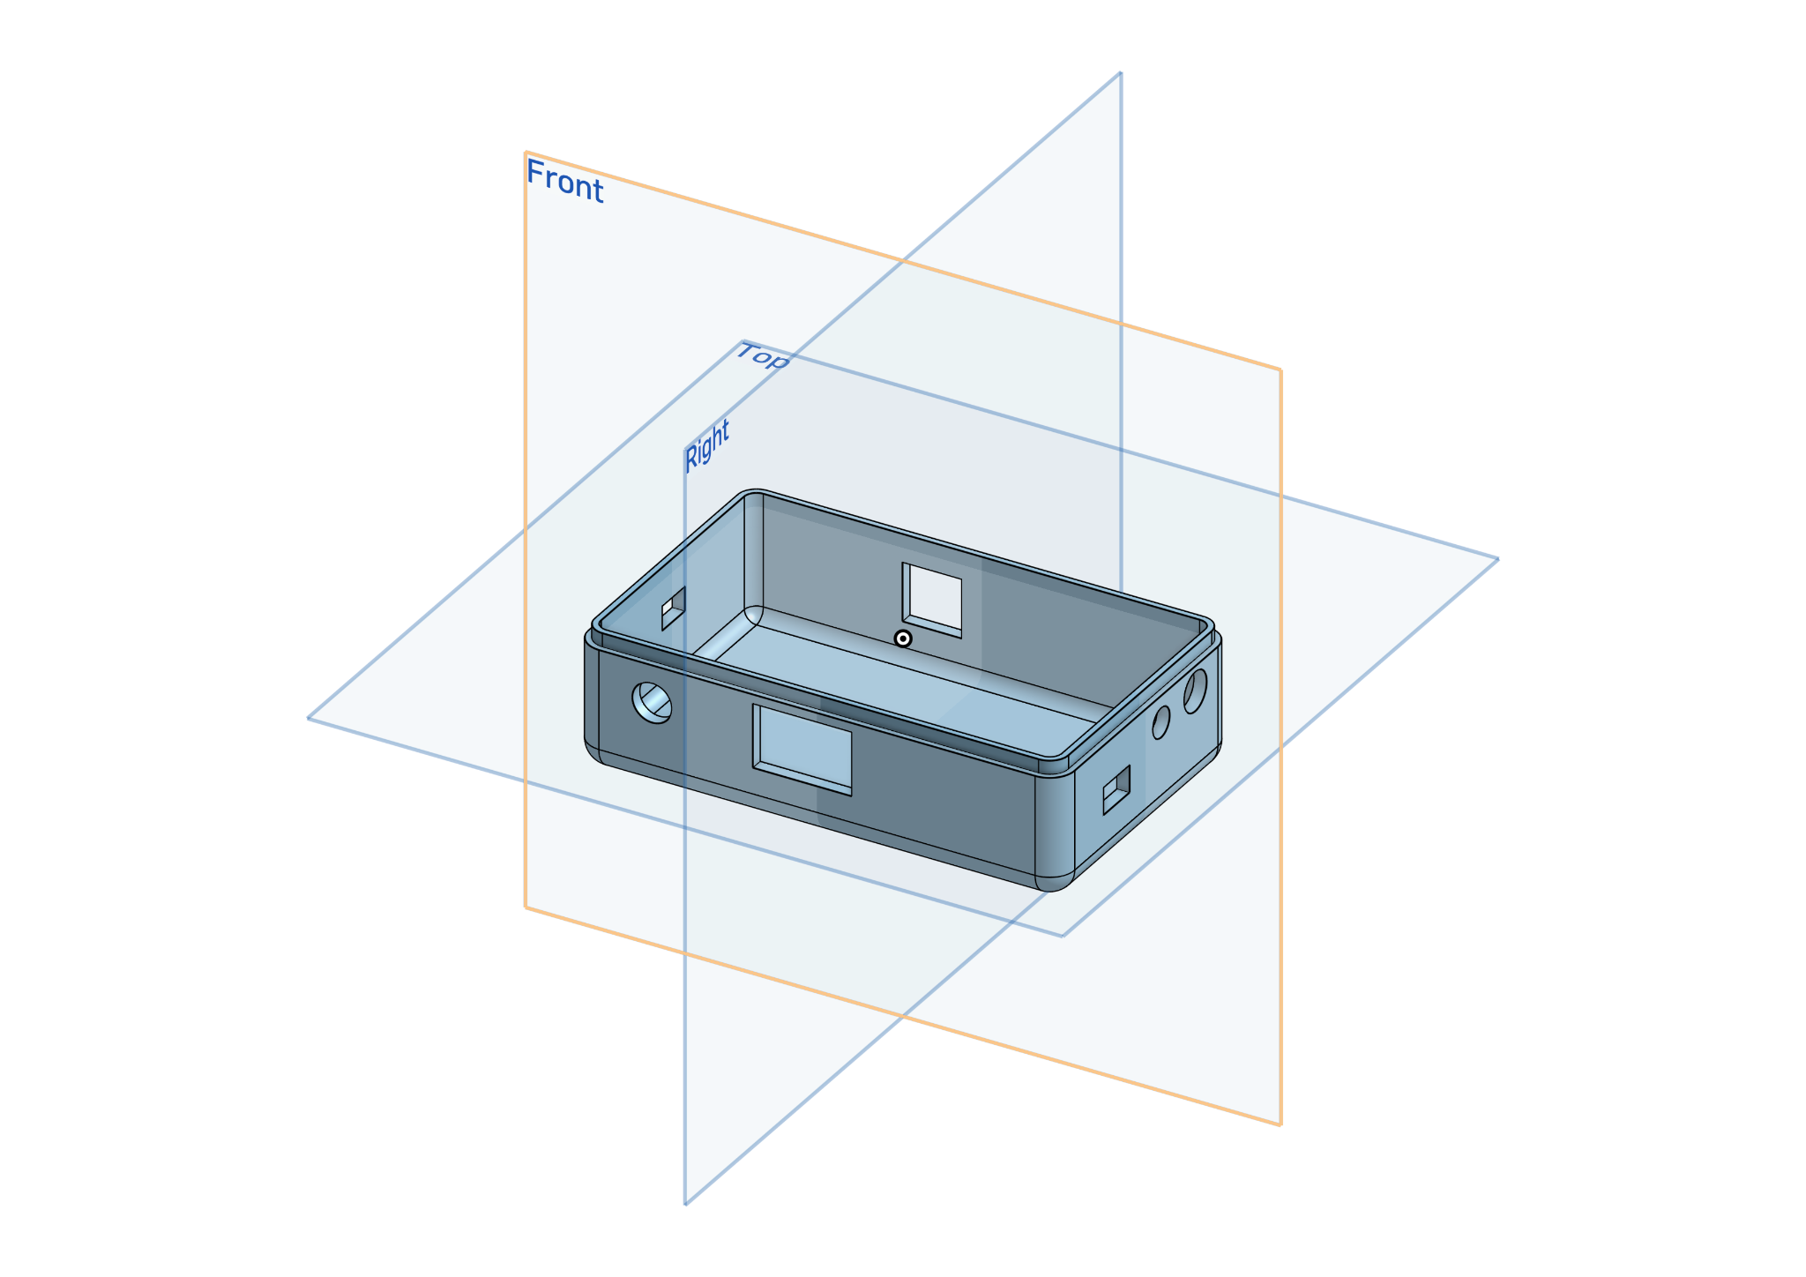

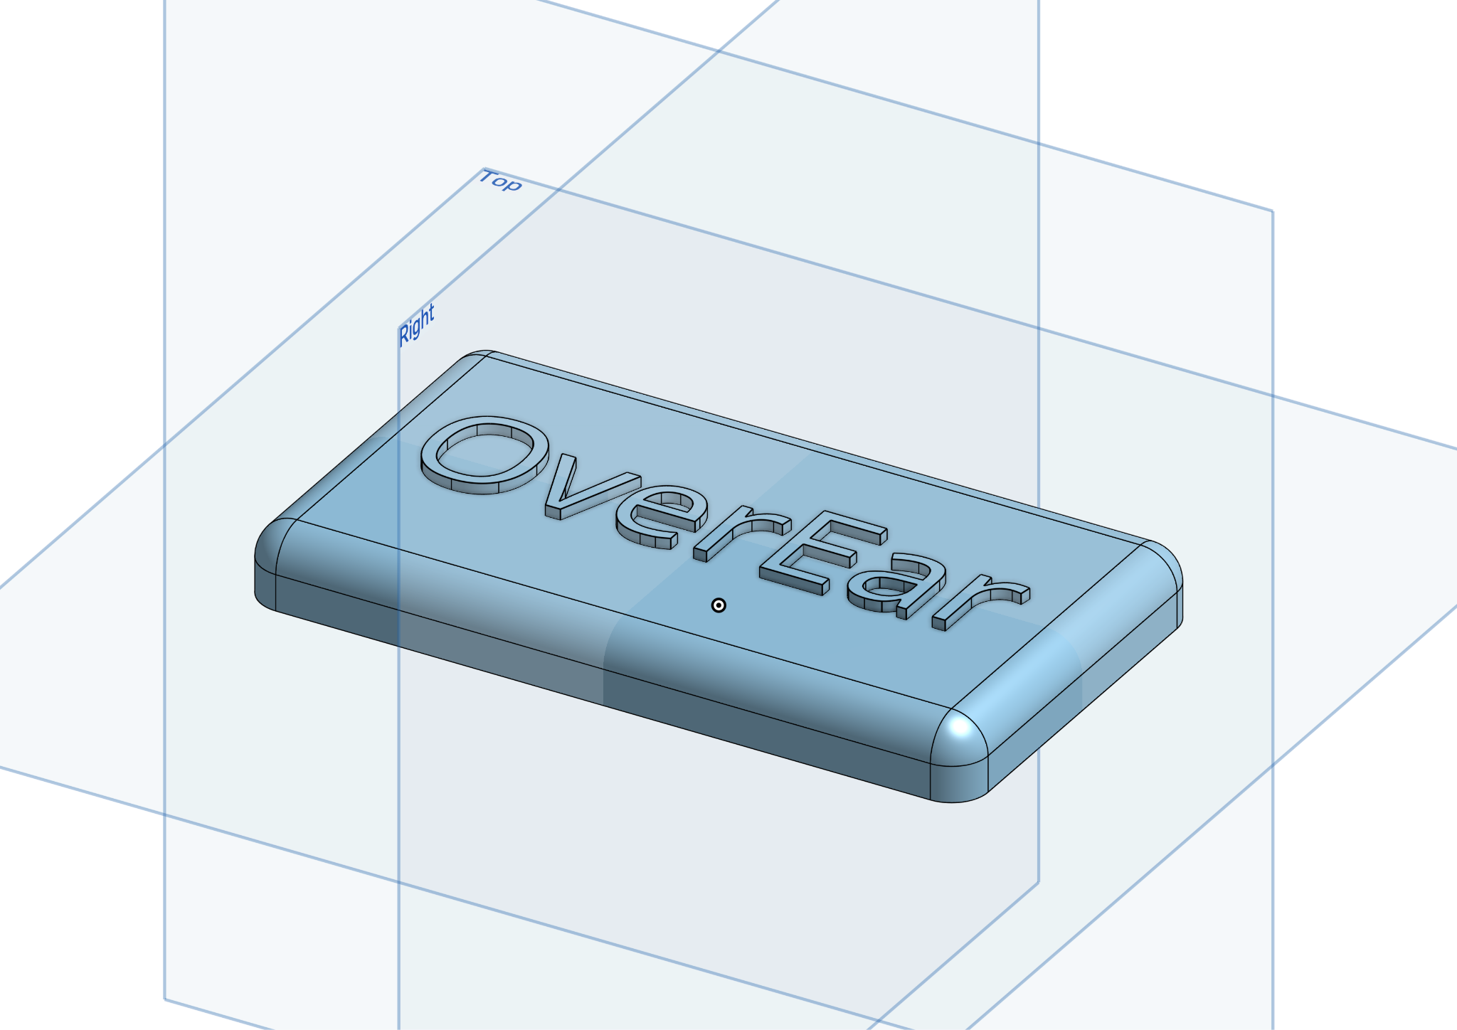

**Figure 2:** Cover for OverEar electronic components

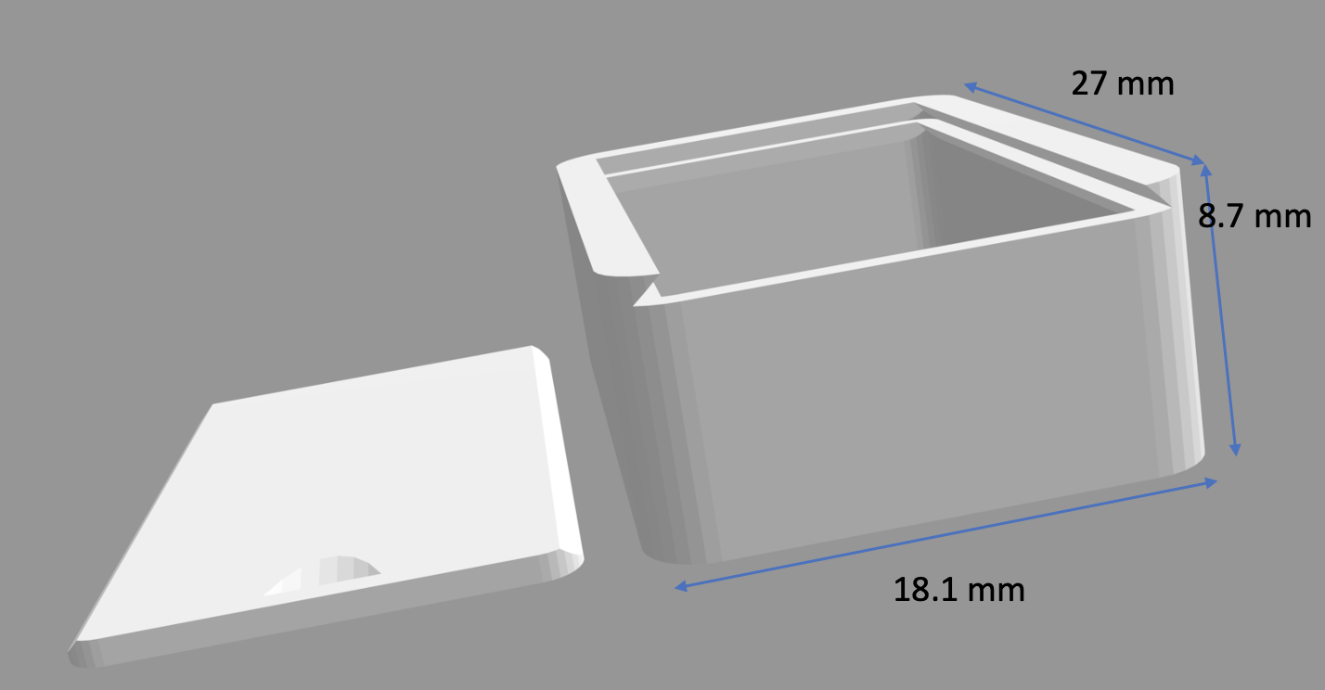

**Figure 3:** Case for microphones

**Criteria 8: Quantitative Test:**

**Objective**

Our goal is to quantitatively measure the effectiveness of our device. Since the device outputs speech, it’s difficult to measure coherency of words numerically, and as such, we aim to measure the muffling capability of the device.

**Materials**

* OverEar device
* Phone speaker

**Variables**

* Independent:
  + Frequency
  + Angle of source
* Dependent:
  + Amplitude over time
* Constants:
  + Distance of source from user
  + Voice recording

**Procedure**:

1. Place the phone speaker at the chosen angle relative to the 0th degree azimuth, directly in front of the user, at a distance of 8cm. For simplicity, the speaker will be at the same height as the user.
2. Play the selected sound recording. The sound clips will change across different frequencies and pitches of voice but kept constant across the different angles.
3. Measure and plot the amplitudes of 3 video clips of voices ranging from low to high frequencies at 3 different angles (-90°, 0°, 90°) after they pass through the device, for a total of 9 measurements. Video clips will be played 8cm from the foam head. Note that -90° corresponds to the right of the user, 90° to the left, and 0° right in front, which is assumed to be the direction of a talker.
4. With any of the video clips placed in front of the foam head, move the volume knob to the left and right. The output level should change with the direction of the knob’s turn.
5. With any of the video clips placed in front of the foam head, press the mute pushbutton switch. There should be no output while the switch is on.

**Results:**

The following graphs were produced using the Arduino Serial Plotter. The values measured in these graphs (orange line) correspond to the output of the device and are the same values passed to the earbuds. Please note that the blue and red lines are constants used to fix the vertical scale of the Serial Plotter.

Low Frequency - Speech by Elizabeth Holmes (<https://www.youtube.com/watch?v=5tEeSHy1x98&t=113s> 2:00)  
It can be seen that with Holmes’ speech, there are large periods where almost no noise is seen on the -90° (Figure 4) and 90° (Figure 6) angles. This is due to the sound-segregation algorithm applying a low-frequency filter, which was a deliberate choice to also reduce background noise.

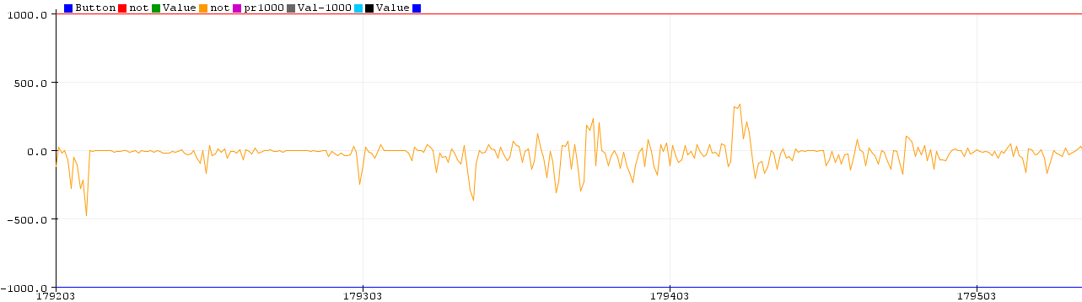  
**Figure 4.** Measurement of Holmes’ audio amplitude from the -90° angle  
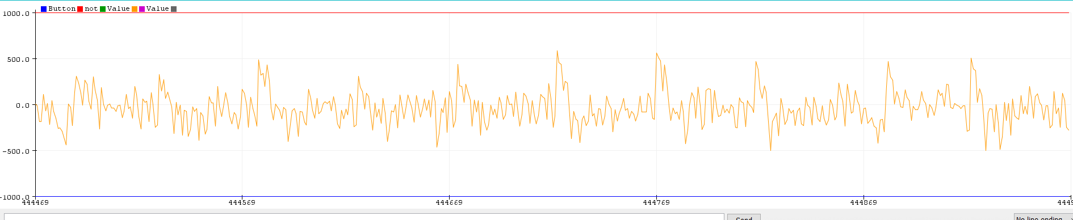  
**Figure 5.** Measurement of Holmes’ audio amplitude from the 0° angle  
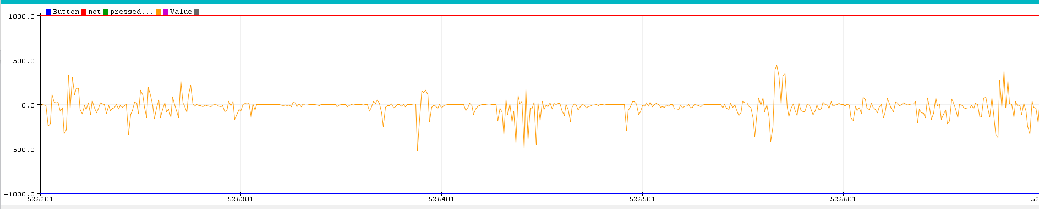  
**Figure 6.** Measurement of Holmes’ audio amplitude from the 90° angle

Middle Frequency - Interview with Mark Cuban (<https://www.youtube.com/watch?v=vrl5PFB35Ec> 2:42)  
With Cuban’s interview, similar large spaces of small amplitudes are seen in the -90° (Figure 5) and 90° (Figure 7) angles. These can be attributed to Cuban’s voice dipping into lower range frequencies. Otherwise, the amplitudes are dampened by the sound-segregation algorithm.

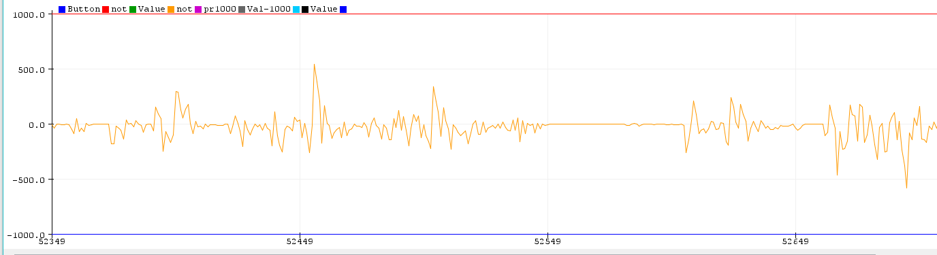  
**Figure 7.** Measurement of Cuban’s audio amplitude from the -90° angle

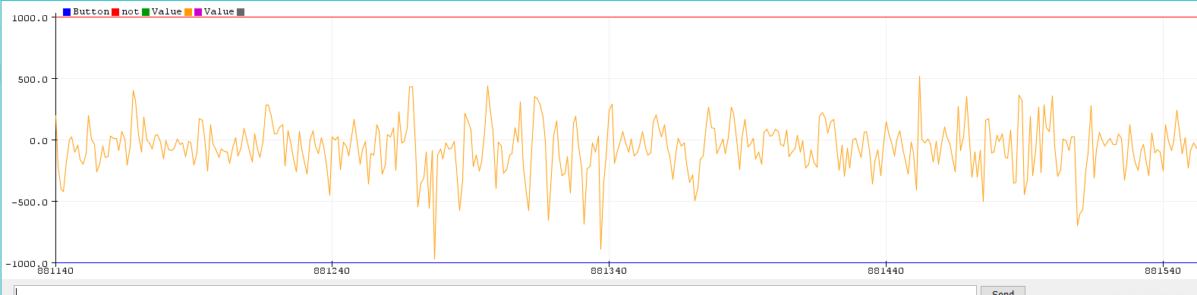  
**Figure 8.** Measurement of Cuban’s audio amplitude from the 0° angle

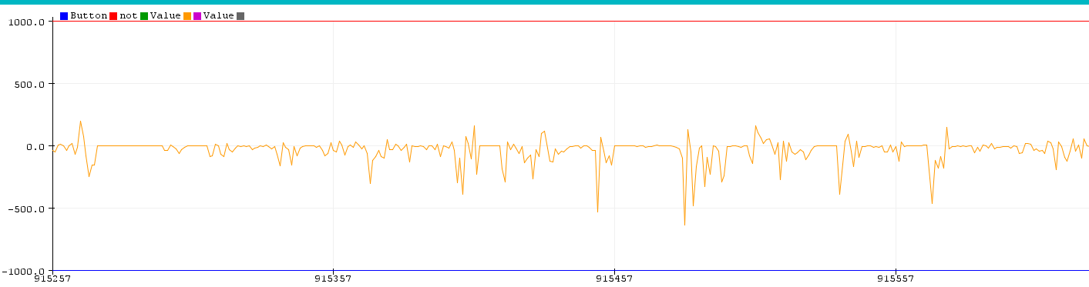  
**Figure 9.** Measurement of Cuban’s audio amplitude from the 90° angle

High Frequency - Interview with Khloe Kardashian (<https://www.youtube.com/watch?v=BtftQFxyzIQ> 0:47)

For the graphs of Kardashian’s interview, it can be seen that from the -90° angle (Figure 8), there are large negative spikes. This can be attributed to the blocking performed by the sound-processing algorithm: due to the sound-memory size, blocks of data are retrieved from the microphones by the Teensy, and there can be data drops because of this, similar to dropped internet packets. This will then change the calculated cross-correlation value. It’s not a large issue as these are very short segments in time, and the usability of the device remains unchanged.

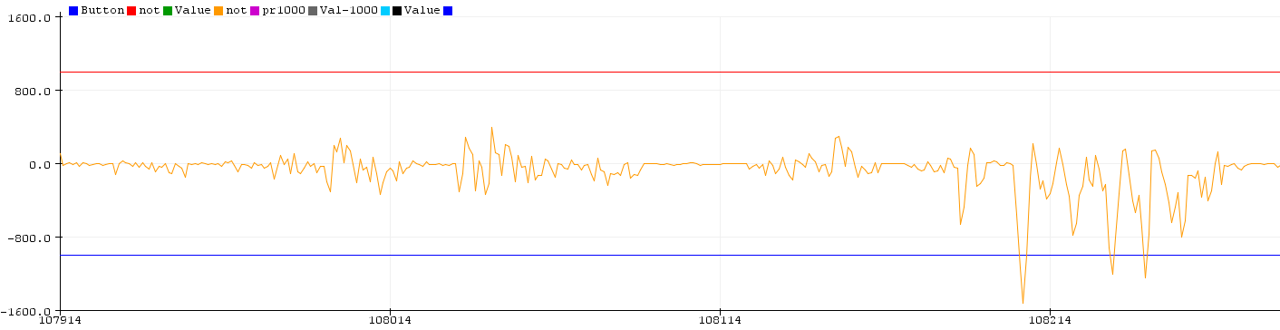  
 **Figure 10.** Measurement of Khloe’s audio amplitude from the -90° angle

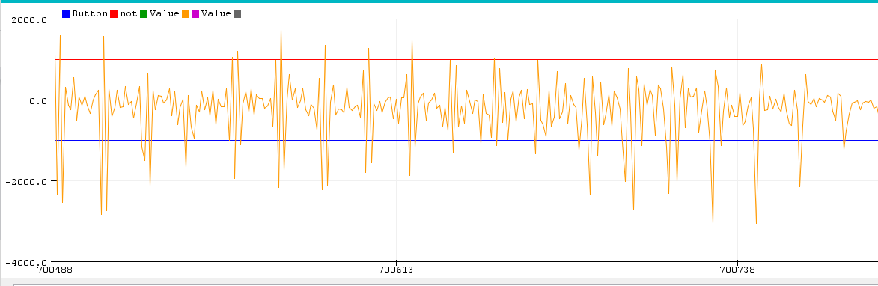

**Figure 11.** Measurement of Khloe’s audio amplitude from the 0° angle

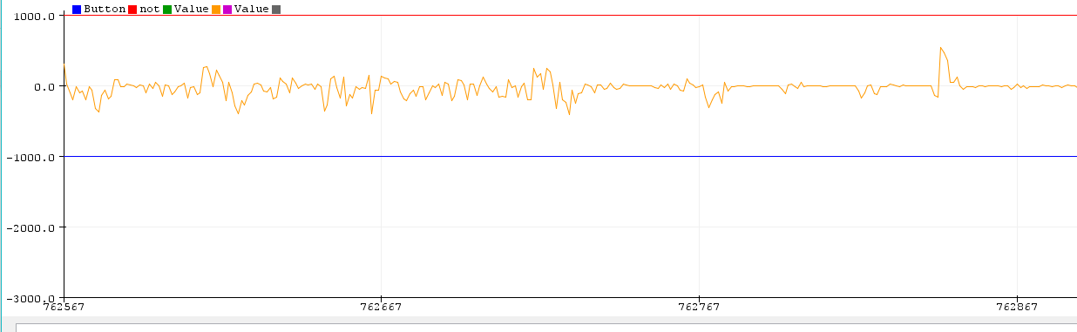  
 **Figure 12.** Measurement of Khloe’s audio amplitude from the 90° angle

In conclusion, we can see that at the -90° and 90° angles, the OverEar device dampens noise while retaining amplitude ranges for the 0° angle. Quantitatively, this shows that our device works as intended. For future testing, we can test more angles and distances to replicate different use cases and determine angle tolerances of our device. Additionally, we can introduce different noise scenarios to observe effectiveness across a range of environments.

**dB vs. Angle Characteristics**

**Objective**

To obtain a solid understanding of the characteristics of the device, we want to measure the attenuation of a constant input across a range of -90 degrees to 90 degrees. This will allow us to perform more accurate analysis of how input samples are changed. We expect the attenuation to decrease as the absolute angle increases, up to 90 degrees.

**Materials**

* OverEar device
* Phone speaker

**Variables**

* Independent:
  + Angle of source
* Dependent:
  + dB over Angle
* Constants:
  + Distance of source from user
  + Frequency of input tone
  + Amplitude of input tone

**Procedure**:

1. Place the phone speaker at the chosen angle relative to the 0th degree azimuth, directly in front of the user, at a distance of 8cm. For simplicity, the speaker will be at the same height as the user.
2. Play the selected tone from a signal generator.
3. Measure the amplitudes of the output at different angles from -90° to 90° in increments of 30° after they pass through the device, for a total of 7 measurements. Note that -90° corresponds to the right of the user, 90° to the left, and 0° right in front, which is assumed to be the direction of a talker.
4. The dB values are calculated using the MATLAB function mag2db which uses a ratio of ydb = 20 log10(y) to determine the dB value. Each measurement taken will be processed and plotted.

**Results:**

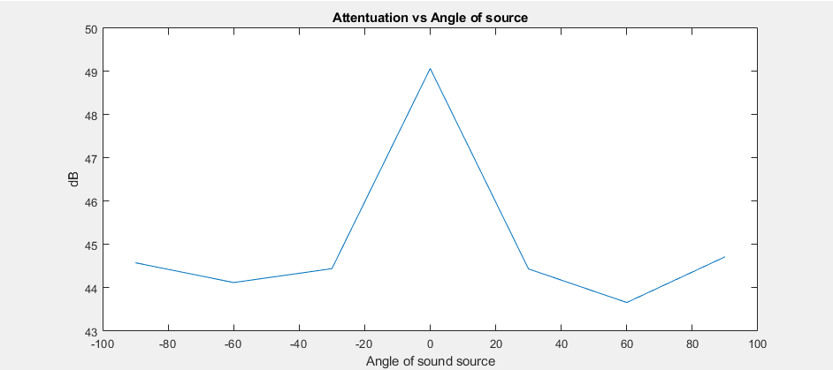

**Figure 13.** Measurement of the attenuation of a constant tone across a range of angles

**Conclusion:**

The above plot shows the effectiveness of our device. As expected the center angle attenuates the source the least. As the absolute value of the angle increases, the amplitude generally decreases. We believe that the differences between the left and right attenuation rates is due to the angle of the microphones. If the microphones are asymmetrically placed, it would follow that a tone played on the left side of the user would be picked up differently by the right side microphone than the corresponding angle on the right side and the left microphone.

For -90° and 90°, the sound output slightly picks up relative to the -60° and 60° respectively. We believe that this is due to the closer microphone in each case picking up so much sound that it overpowers the contribution of the microphone further away. To elaborate, the closer microphone samples a value so high that despite a lower cross correlation value, the resulting product of the two is still larger relative to -60° and 60°. Since the microphones are aligned normal to the side of the head, at -90° and 90° input is directly picked up by the microphone while -60° and 60° sounds are received at an angle.